Northstar Dance Company Audition
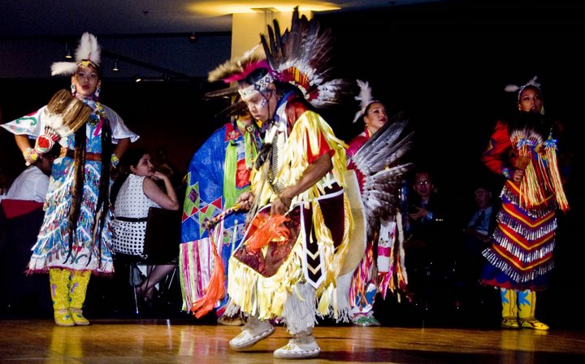
- When: Sunday, November 1, 2009 @ 2pm
- Where: THPRD Garden Home Recreation Center (Studio 2)
7475 SW Oleson Rd, Portland, OR 97223
Audition Virtual Location Map
http://paintedsky.org/about/contact.php

Northstar Dance Company is having an open audition for all Native style dance including Hoop (for both Men and Women). All participants must be age 16 or older (dancers under 18 years of age need to have a parent present). Please bring your Regalia outfit to the audition.

What we’re looking for:
- Dancers who are able to change up Native styles
- Background in contemporary styles of dance a plus
- Positive Attitude and Attendance Reliability
- Stage presence
- Must be able to travel

Northstar Dance Company Benefits:
- Involvement in the cultural performing arts
- Paid stipends and performance compensation (Per Contracted Season)
- Work with professional Choreographers and Outfit Coordinator
- Stage Performances
- Health and Fitness

If you have any questions, please contact us at:

www.paintedsky.org
www.myspace.com/northstardancers
503.887.0671

Northstar Dance Company believes in the passion of the dance and encourages those who believe the same to come to the audition and represent!

