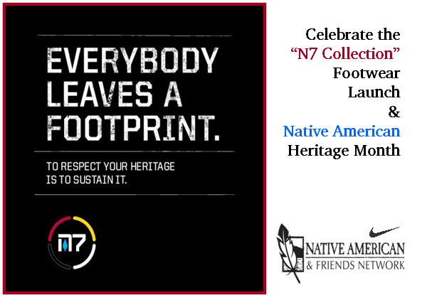

Please join Nike's Native American & Friends Network (NAFN) as we begin our Native American Heritage Month Celebration by hosting a national product launch for Nike’s new N7 Collection! There will be thirty-four launch locations across the US.

The N7 Collection is Native inspired in design, built with low environmental impact materials and the profits from shoes go back into the N7 Fund (Let Me Play on Native Lands) http://www.letmeplayonnativelands.org/.

Date: Saturday 11/07/09
Time: 10 AM to 12 PM
Place: *Nike’s Beaverton Employee Store (BES)
3485 SW Knowlton Rd. Beaverton, Oregon 97005

The event will include Native American dancers from our community, a music DJ to shake things up, shopping for the N7 Collection products and you might even win one of our great raffle prizes. If anyone wants to dress in their regalia or outfits, please do!

Important!
*The Nike Beaverton Employee Store location is not a public shopping location. If you or your family and friends plan to attend the N7 collection launch at this location, you must be on the guest list.

To learn more about the N7 Collection of footwear, please visit: http://www.facebook.com/NikeN7

